**Selenium Wait**

**What are Wait commands in Selenium?**

The wait commands are essential when it comes to executing Selenium tests. They help to observe and troubleshoot issues that may occur due to variation in time lag.

While running Selenium tests, it is common for testers to get the message “Element Not Visible Exception“. This appears when a particular web element with which WebDriver has to interact, is delayed in its loading. To prevent this Exception, Selenium Wait Commands must be used.

In automation testing, wait commands direct test execution to pause for a certain length of time before moving onto the next step. This enables WebDriver to check if one or more web elements are present/visible/enriched/clickable, etc.

Selenium WebDriver provides three commands to implement waits in tests.

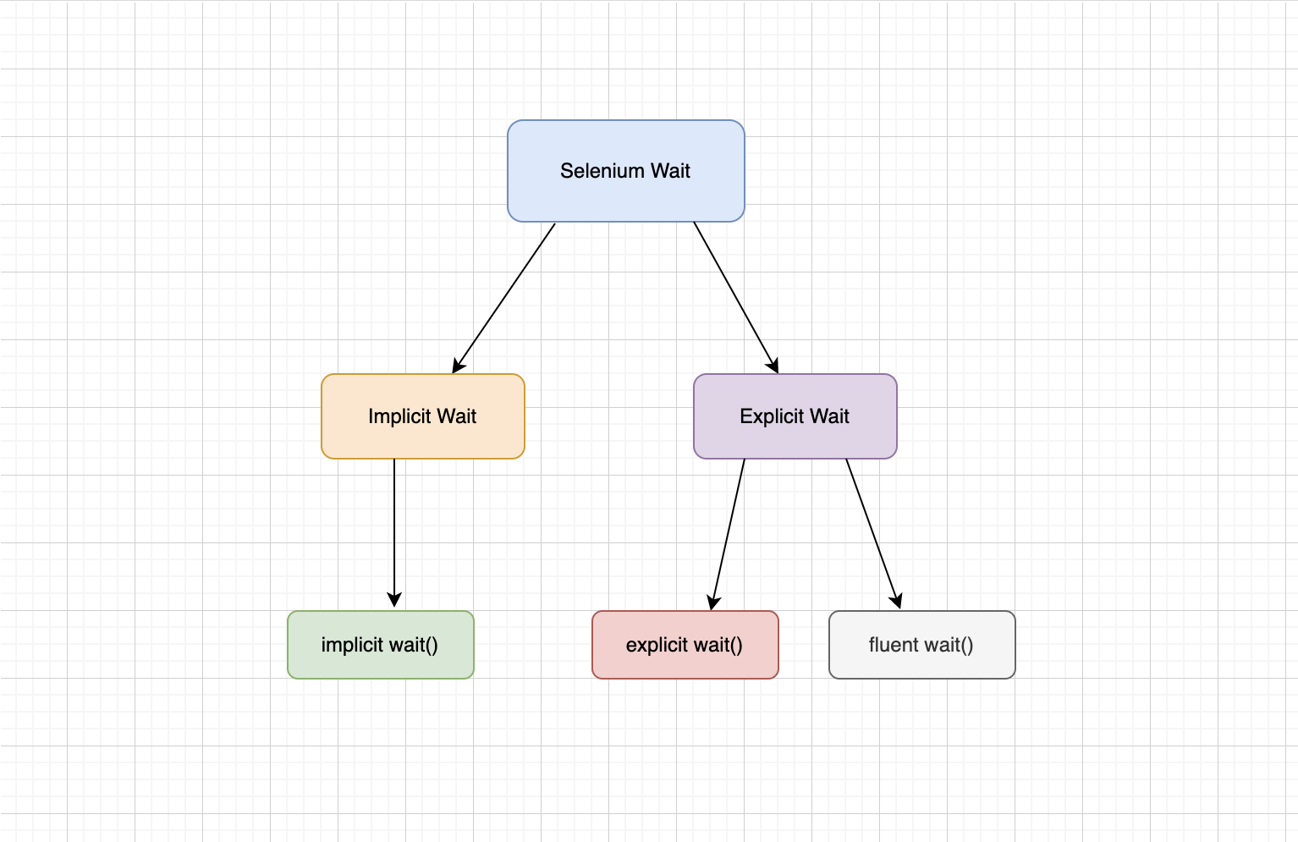

Implicit Wait: - During implicitlyWait, the WebDriver will ***poll*** the DOM for certain specified time units while trying to find any element. If the element is found earlier, the test executes at that point otherwise the WebDriver waits for the specified duration.

Syntax

driver.manage().timeouts().implicitlyWait(10, TimeUnit.SECONDS);

**Explicit Wait**

An explicit wait is a conditional wait strategy in Selenium in other words you wait until the condition you specified becomes true or the time duration has elapsed. Since explicit wait works with a condition, they help in synchronizing the browser, document object model, and the test execution script. Hence, the overall execution results are satisfactory and time-bound. Explicit wait provides the following conditions for usage:

* *alertIsPresent()*
* *elementSelectionStateToBe()*
* *elementToBeClickable()*
* *elementToBeSelected()*
* *frameToBeAvaliableAndSwitchToIt()*
* *invisibilityOfTheElementLocated()*
* *invisibilityOfElementWithText()*
* *presenceOfAllElementsLocatedBy()*
* *presenceOfElementLocated()*
* *textToBePresentInElement()*
* *textToBePresentInElementLocated()*
* *textToBePresentInElementValue()*
* *titleIs()*
* *titleContains()*
* *visibilityOf()*
* *visibilityOfAllElements()*
* *visibilityOfAllElementsLocatedBy()*
* *visibilityOfElementLocated()*

#### **WebDriverWait command in Selenium**

WebDriverWait specifies the condition and time for which the WebDriver needs to wait. Practically, WebDriverWait and explicit wait go synonymously as their definitions and usage match perfectly. So if someone asks you to write some explicit wait scripts, it is safe to assume that the required scripts demand WebDriverWait.

WebElement firstResult = new WebDriverWait(driver, Duration.ofSeconds(10))

.until(ExpectedConditions.elementToBeClickable(By.xpath("//a/h3")));

#### **Fluent wait in Selenium**

The fluent wait is similar to explicit wait in Selenium with one additional argument of frequency (also known as polling time). The frequency number tells the WebDriver to keep checking for the element at regular intervals and wait till the maximum of ***"Duration.ofSeconds"***. This saves execution time. If the element becomes available earlier, we can proceed with our execution and finish quickly.

Wait<WebDriver> wait = new FluentWait<WebDriver>(driver)

.withTimeout(Duration.ofSeconds(30))

.pollingEvery(Duration.ofSeconds(5))

.ignoring(NoSuchElementException.class);